Viewing Data using MSView

Here’s how to view live data using MSView:

First, download MSView from Morningstar’s Corporate Website, located here:

<https://www.morningstarcorp.com/msview/>

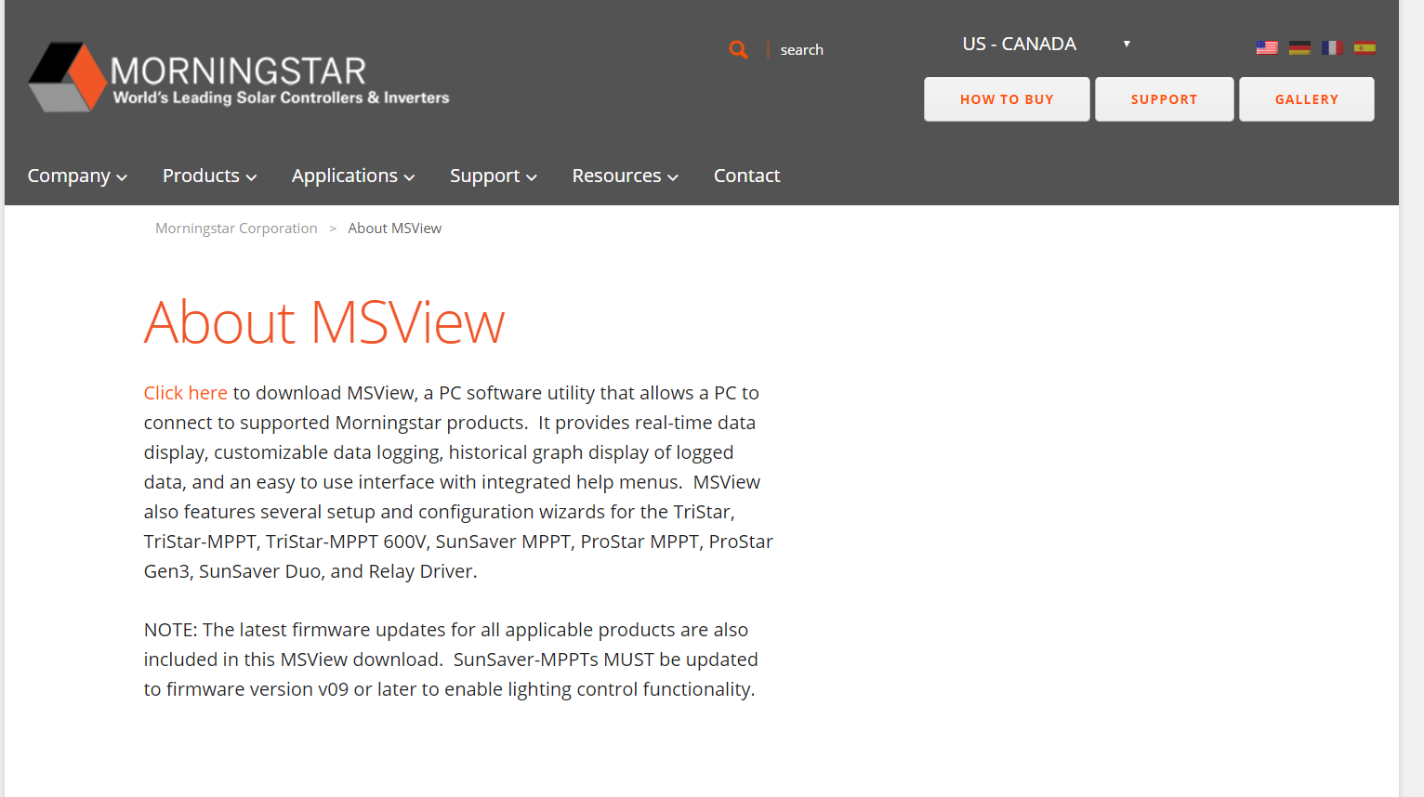

If you’re using a RS-232 to USB serial connector to connect your PC, connect it now.

Connect a 12V power supply to the battery terminal of the Tristar MPPT Charge Controller. It should draw approximately 189mA of current just for management.

Open MSView.

Under Devices, select Search for Connected Devices. Your Tristar MPPT should show up under whatever virtual COM port you connected your RS-232 to USB connector to. Double-click it. You should see something like this appear.

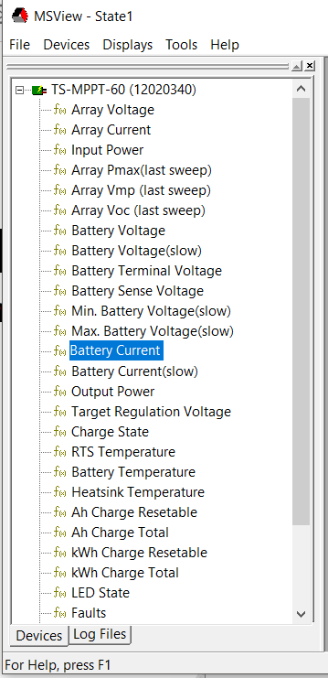

To view live data, do this:

Under Displays, select New.

Select ‘State’ when a dialog box saying New Display appears and press OK.

Drag and drop whatever variables you want. Our Tristar MPPT can log Array Voltage (Array is shorthand for our solar panel array), Array Current, Input Power (how much power our solar panels are producing), Array Pmax, Array Vmp, Array Voc, Battery Voltage (The Voltage of our Battery), Battery Voltage (slow), Battery Terminal Voltage, Battery Sense Voltage (there’s a remote voltage sensor port on our Tristar MPPT that we can connect for safety), Min. Battery Voltage (slow), Max. Battery Voltage (slow), Battery Current, Battery Current(slow), Output Power (how much power we’re consuming), target regulation voltage, charge state (Float, equalization, etc.), RTS temperature, Battery Temperature, Heatsink Temperature, Ah Charge Resetable, Ah Charge Total, kWh Charge Resetable, kWh Charge Total, LED State, Faults (did someone change the DIP switch?), Faults Daily, Alarms (did someone overcharge?), Alarms Daily, Hourmeter (how long have we been using this thing?), and Settings Switches(the state of our DIP switch).

Programming the Tristar MPPT using MSView:

There are many different types of batteries: Lithium Ion, Lead-Acid, Lithium Polymer batteries, LiFePO4 batteries, etc. Each one of them requires its own different programming.

The Tristar MPPT has 7 built-in programming things.

To custom-program our Tristar MPPT to handle a battery, follow these steps:

Under Tools, click Tristar MPPT Setup Wizard. Read and click OK for both of the warnings against switching DIP switches while the power is applied.

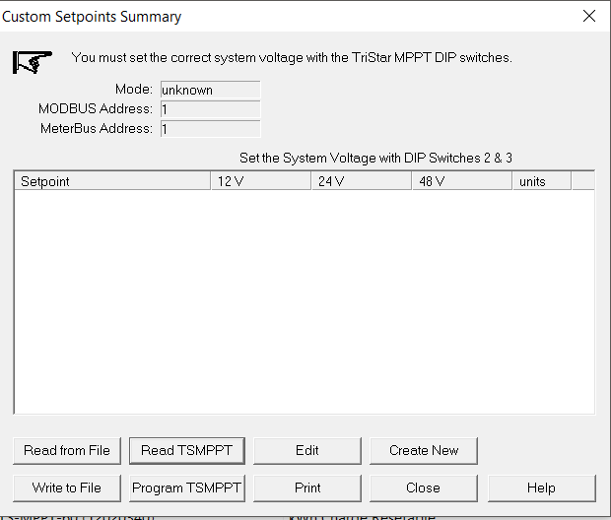

Click Read TSMPPT.

Make sure it’s set to Solar Charge Control.

If you’re using a serial connection, make sure you’re using the right COM port.

On our Tristar MPPT, the MODBUS address is 1.

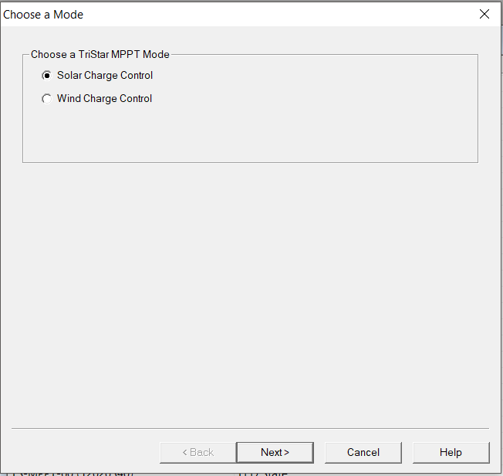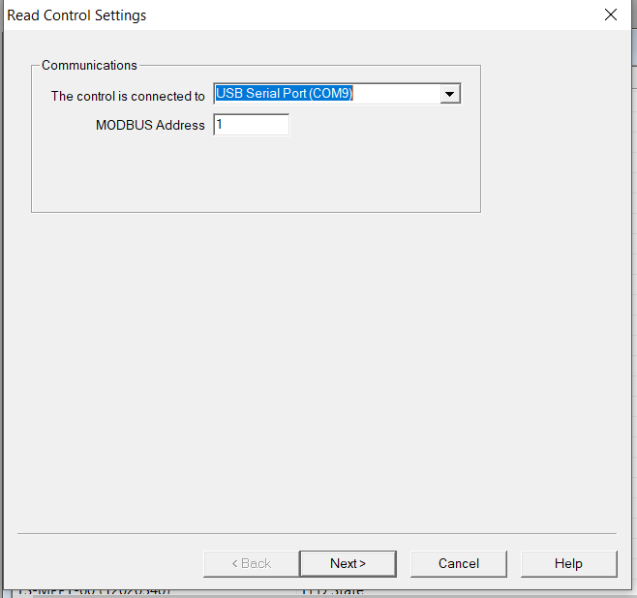

The Setup wizard should look something like this afterwards if reading the settings was successful.

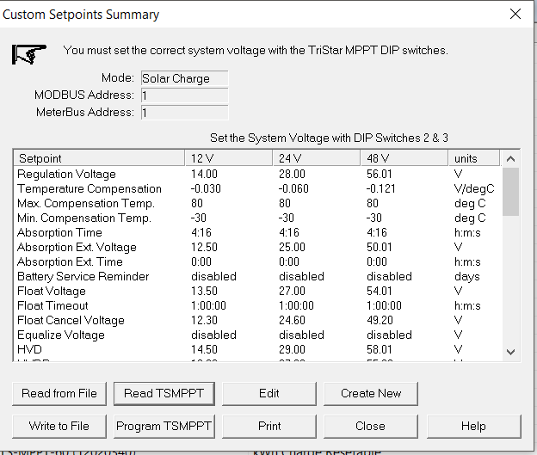

Read the settings you extracted from the Tristar MPPT first before you reprogram it. If the settings are not to your liking (i.e. the batteries will not charge properly), you can reprogram the Tristar MPPT. If you have a file already saved, click Read from File, and all your previously made changes will be loaded.

If you don’t have a file made already, then click Edit. This will allow you to make your own custom settings.

You can change all these settings shown below:

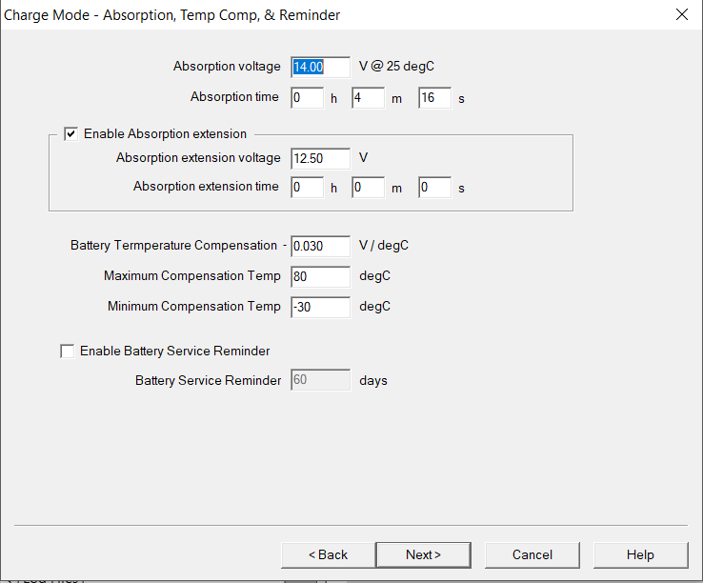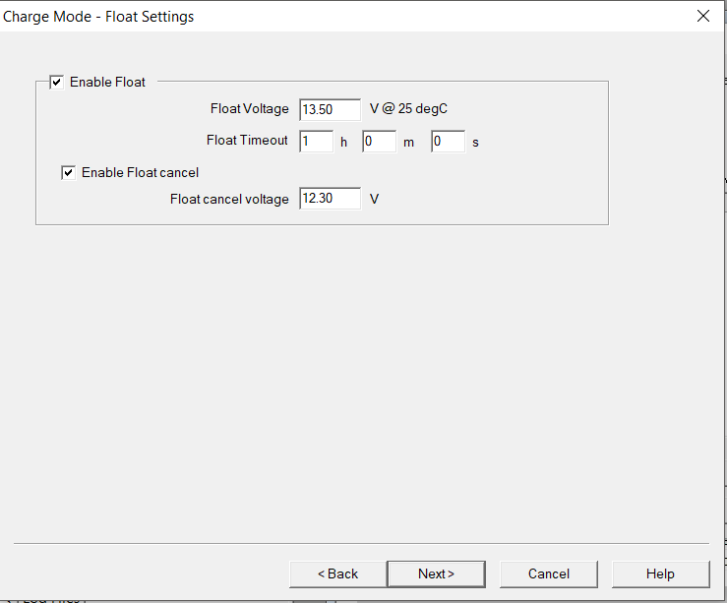

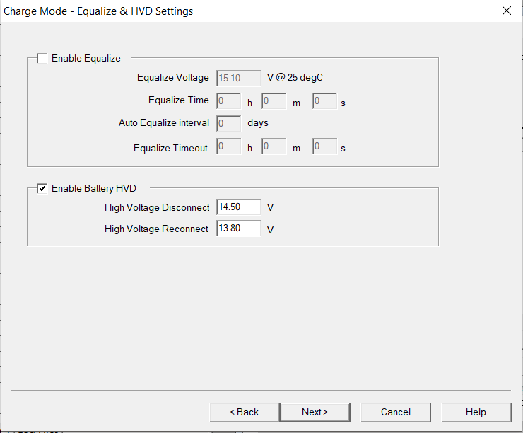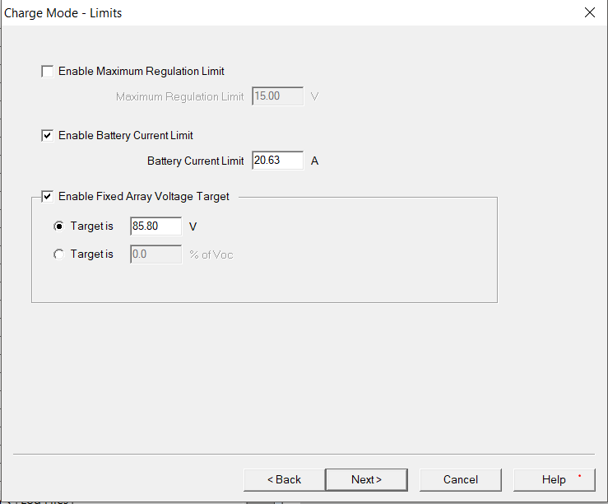

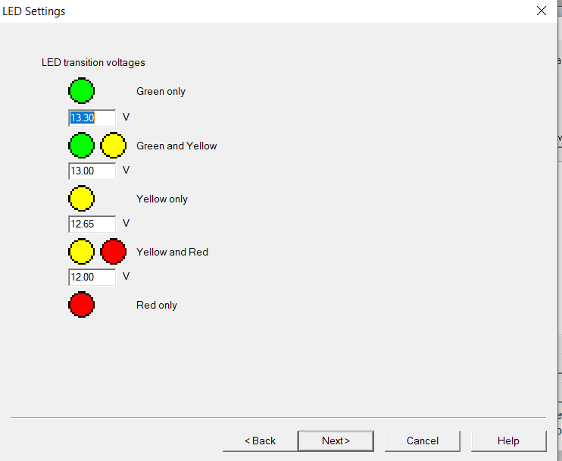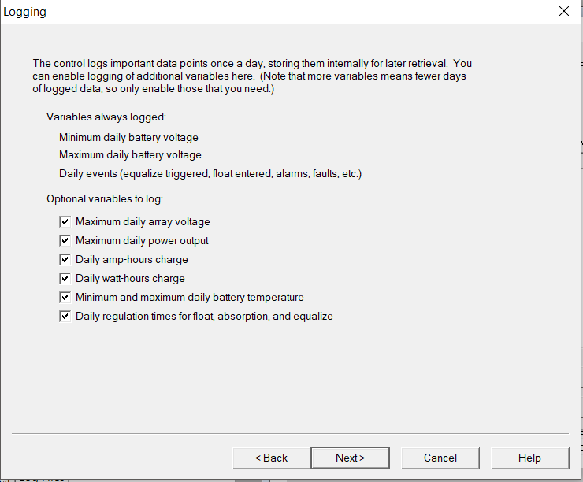

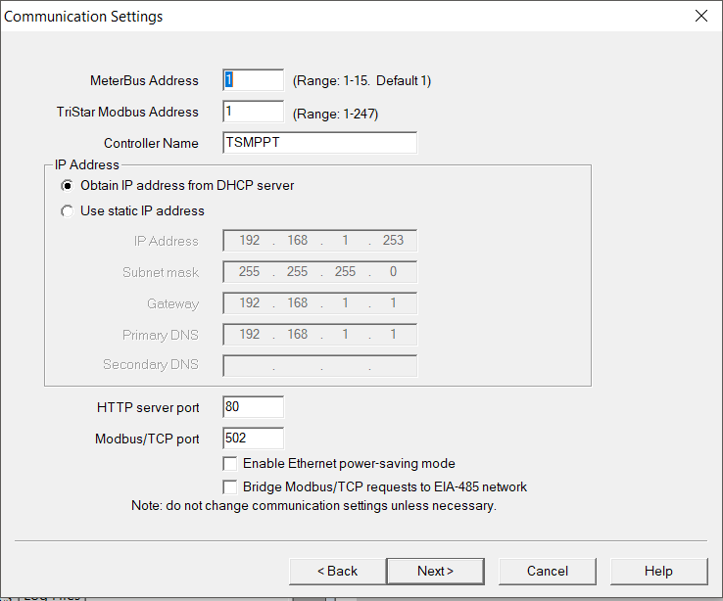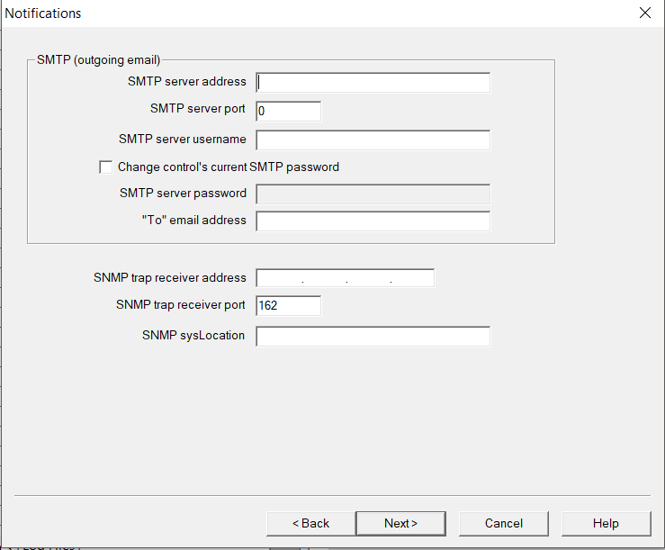

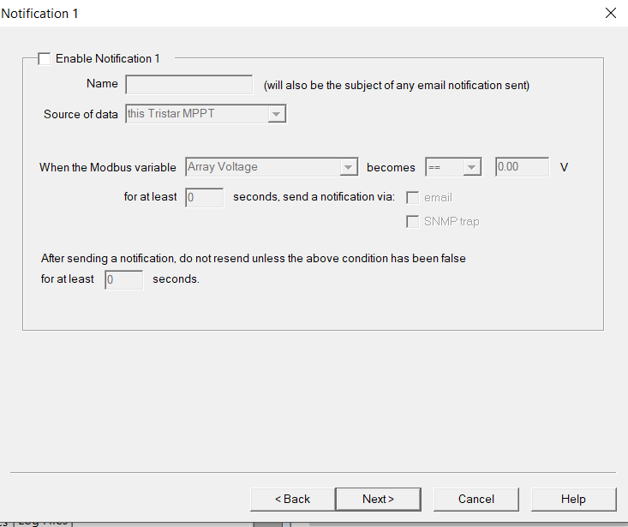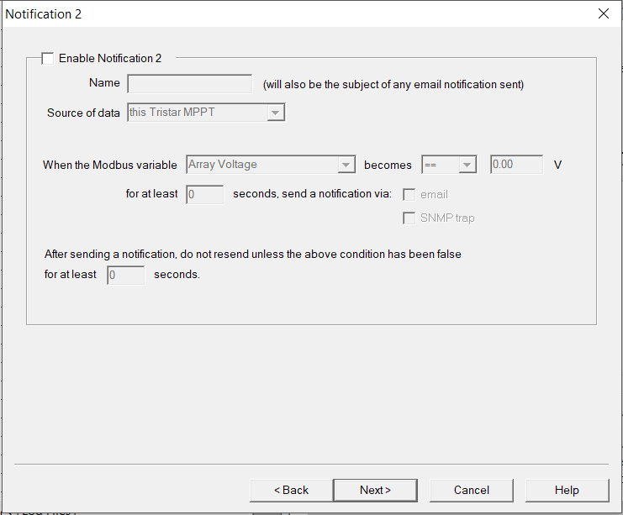

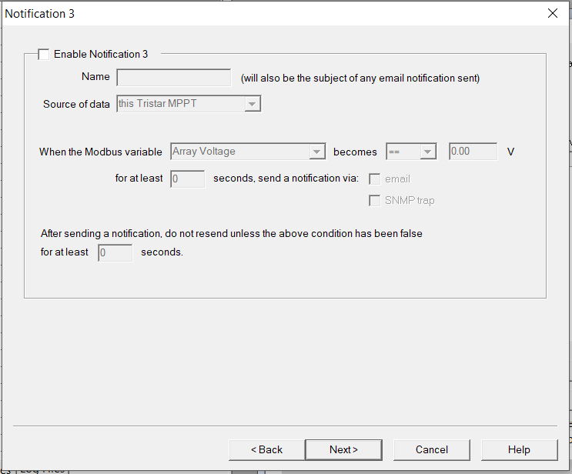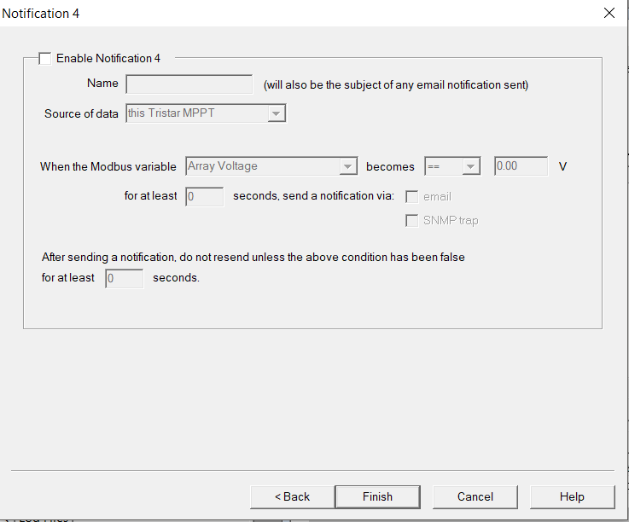

Once all of your changes are made, you can save it to a file, just in case you need to reprogram the Tristar MPPT. Save it by using Write to File.

Once you have your settings loaded, you need to program the Tristar MPPT. Click Program TSMPPT, and make sure the COM port is correct.

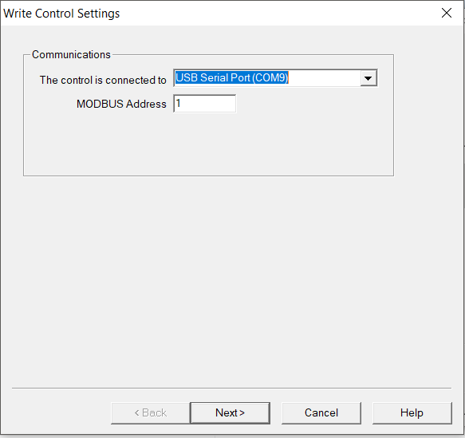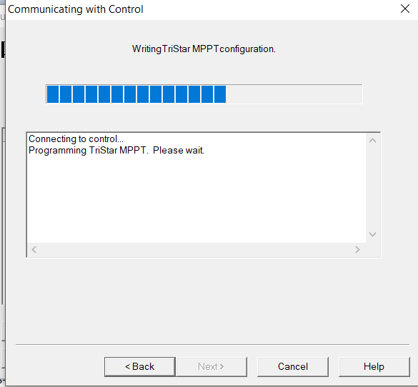

Now, your Tristar should be ready to be used with your batteries!

Oh, one more thing! If you want to use custom charging settings, DIP switches 4,5, and 6 must be switched on! That’s how the custom settings work! It even says so in MSView!

Also, this is a CHARGE CONTROLLER! It won’t manage all your batteries for you! You must use a BMS system for that. Luckily, we have one. I’ve got a separate document for that. It can help you balance out the charges on your batteries so that every battery has an even charge, and none of them use too many life cycles at the same time.